Shell Tutorial

**Part 1 (Some Basic Commands)**

**Overview:**

1. Basic Introduction about shell
2. Shell Vs Graphical User Interface(GUI)
3. Basic Commands

**What is Shell?**

Shell in Unix is a user interface that is used by a user to access Unix services.

Generally, a Unix Shell is a command-line interface (CLI) in which users enter commands by typing or uploading a file.

**Shell(CLI) Vs Graphical User Interface (GUI)**

A GUI (Graphic User Interface) is a graphical representation in which the users can interact with software or devices through graphical icons.

A CLI (Command Line Interface) is a console or text-based representation in which the user types the commands to operate the software or devices.

**Basic Commands**

1. **pwd** – This command is going to give the Present Working Directory.

If you want to know your current working directory then you can easily type “pwd” and it will give you the present working directory.

As here, I am currently present in a directory named “smarty” which is present in the root directory “home”.

C:\Users\smarty\Desktop\Capture1.JPG

Now how will you read “/home/smarty”?

It means, in the root directory “home” there is another directory smarty on which you are currently working.

1. **ls** – This command will list all the files, directories in the PWD

If you want to see all the directories or files present inside your present working directory, so you can simply type the command “ls” and it will give a list of all the available directories and files.

As previously, I was in /home/smarty, Now if I type the command “ls” it is going to list all the Directories and files present inside the pwd(here it is smarty)

C:\Users\smarty\Desktop\Capture2.JPG

1. **cd** – This command will change the current directory to the next desired directory

If you want to change your current directory and want to go to another directory let’s say “Desktop” then you can simply type the command cd Desktop, and

then if you type pwd then it will give /home/smarty/Desktop

C:\Users\smarty\Desktop\Capture3.JPG

Now a question arises, what will happen if I type “cd xyz”. In this case, it is going to give an error because as shown in the previous “ls” command we don’t have any xyz directory.

So from the present working directory, you can move to only those directories which are available in pwd.

1. **cd ..** – This command is used to move up a directory.

If you want to get back to the previous (parent) directory then you can use the command “cd ..”

As previously, I moved to Desktop so my pwd was “/home/smarty/Desktop” but after implementing the command “cd ..” my directory got changed to /home/smarty

C:\Users\smarty\Desktop\Capture4.JPG

1. **cat** – This command is used to see the content of a file.

Here, we are having a file original.txt on Desktop and it contains a simple text line “Basic Shell Commands” as shown.

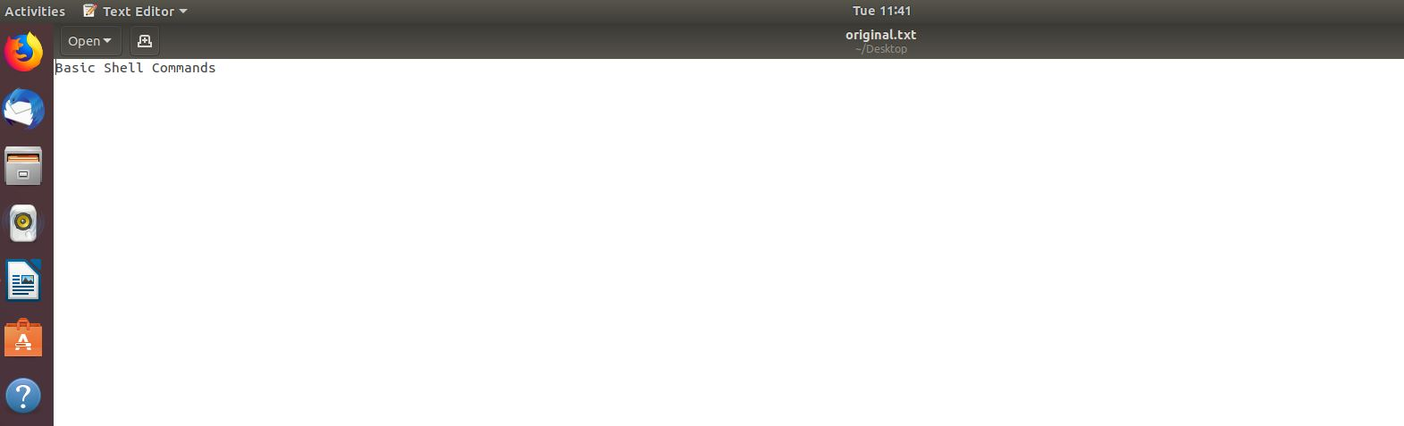

Now, if you want to see the content of this file using shell we can do it by using the command.

“cat original.txt”.

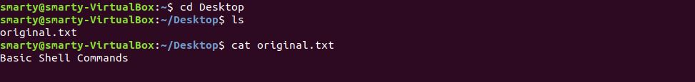

1. **cp** – This command is used to copy the file(copy-paste).

If you want to copy any file let’s say original.txt and want to save it with a new name “temporary.txt”. Then you can use this command to do so.

As here, initially, we don’t have the file name “temporary.txt” but now after implementing the command “cp original.txt temporary.txt” it creates a new file temporary.txt having the same content in it as it was in original.txt

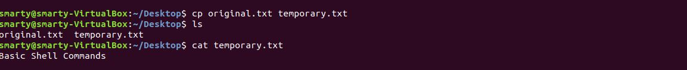

1. **mv** – This command is used to move the file (cut-paste).

If you want to move a file from one location to another, then you can use this command to do so.

Here I move the file “temporary.txt” to “temp.txt” in the same directory “/home/smarty/Desktop”.

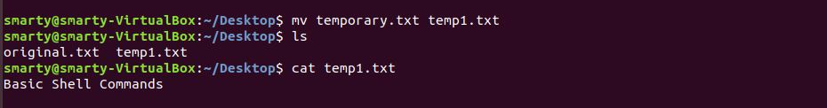

Now if suppose, I want to move the file original.txt which is present in the directory “/home/smarty/Desktop/” to a file temp.txt in new location “/home/smarty”. So, we can do it with the command,

mv original.txt /home/smarty/temp.txt

mv <source> <Destination>



1. **Rename** – Again ‘mv’ command can be used to rename a file.

As here we are having a file named “temp1.txt” and I want to change its name to “renamed.txt”, I can do so by simply using the command

mv temp1.txt renamed.txt

mv <file_path_with_old_name> < file_path_with_new_name >

C:\Users\smarty\Desktop\Capture8.JPG

1. **rm** – This command is used to remove the file.

If you want to delete a file, you can do it by using this ‘rm <source or file_path>’ command.

Like here I want to remove the file “renamed.txt”, so I deleted this by using the command “rm renamed.txt”

C:\Users\smarty\Desktop\Capture9.JPG

1. **mkdir** – This command can make a new directory

If you want to make a new directory then you can make it easily by using the command “mkdir <directory_name+locatio>”.

Here I want to make a new directory named “tutorial_series” on the Desktop, and as I am currently on desktop so I can make it simple by using the command

“mkdir tutorial_series” as shown,



Now if my pwd is smarty, but I want to make a new directory “xyz” on desktop, so I can do it by giving the desired path along with the Directory name.

mkdir /Desktop/xyz

Do you know the difference between Directory and Folder?

*Folder is just a Graphical User Interface version of Directory.*

1. **rmdir** – This command can remove the directory

If you want to remove a directory, then this command can help you to do so.

E.g. If I want to remove the directory tutorial_series, it can be done by using the command “rmdir tutorial_series”.

C:\Users\smarty\Desktop\Capture13.JPG

created by Vidit